

CSU SACRAMENTO DEPARTMENT OF ENGINERING

Class: EEE 117L-06



Author: Professor

Miguel Tirado S. Aguilar

Partners:

Gabriela Munoz, Xiomara Validivia

**1 Introduction**

An oscilloscope is a useful tool used to measure signal voltages on a 2-Dimensional plot as a function of time. This means we can observe waveforms in the form of sin, cos, square and more on the screen. The oscilloscope can measure the waveforms amplitude, frequency, period and much more. It is a very versatile tool however most oscilloscopes can’t measure current that’s why my team and I use a digital multimeter to verify are measurements on the oscilloscope. The digital multimeter can measure current, resistance, and voltage. Thus, making the DMM a useful tool to use alongside the oscilloscope however the oscilloscope can measure waveforms with out a source producing those waveforms. That is where the function generator comes into play as it produces electrical waveforms over a range of frequencies. The Function generator will be used with the oscilloscope and the DMM in this lab. The team and I will make observations about the oscilloscope’s readings with calculations to verify that our readings are accurate. My team and I used Kirchhoff’s current law and node analysis to calculate for our R value that will give us a 45-degree phase shift.

**2 Purpose**

The purpose of this lab is to provide my team and I experience with the oscilloscope along with the function generator and the DMM (Digital Multi Meter). There are four main groups of control on the oscilloscope being input (vertical controls, time base (horizontal) controls, trigger controls, and the final is the measurement section. The vertical controls can be found on the bottom left the oscilloscope. The horizontal controls the time displayed on the horizontal axis. The trigger controls synchronize the horizontal sweep time with the input signals. The measurements provide the voltage, time and much more measurements. In this lab will focus on three main parts which are I Vertical Controls, II Triggering Controls, and III Measurements.

A picture containing screenshot, map

Description generated with high confidence

**3 Discussion and Analysis**

Part I Vertical controls first step was to select channel 2 and verify that the oscilloscope is on the “AUTO” mode. Next my team and I set the “Coupling” to ground and find the trace specifically the caret on the right vertical axis. Now my team and I observed the caret as the vertical position knob from channel 2 was being rotated. Now we set the vertical position so that ground is in the center. My team and I observed that initially when rotating the knob, the trace remains the same on the ground level while the only thing changing was the time/divisions.

Now my group and I changed the setting from ground to DC and used the x10 probe to connect it to the calibrator voltage to channel 2 input. Then we changed the time base controls so that there are 4 cycles of the calibrator voltage on screen. Now we measured the peak to peak calibrator voltages with the probes on x1 and x10. Our oscilloscope did not have a x100 setting therefore that step was removed from our lab. Now we measured the calibrator voltage for the x1 and the x10 probe. From the readings my group and I could tell that both were correct the only difference was there time/divisions. For the x10 scope we had to multiply 2.48V by 10 in order to get the correct voltage peak to peak.

|  |  |  |
| --- | --- | --- |
| Oscilloscope | Time/div | Voltsp-p |
| X10 | 1.24 | 24.8 |
| X1 | 12.4 | 24.8 |

Now we verify that channel 1 is on DC and that the probe is set on x10 and use it to connect it to the function generator to channel 1 of the oscilloscope. Now we set the trigger source to channel one and set the function generator for a 1KHz sinusoid with a 1 Voltp-p amplitude on a 0-volt dc offset. Now set the oscilloscope up to display 4 cycles of the sin wave. Next, we add a DC offset of 1 volt on the function generator and observe the trace. My group and I noticed that the 1-volt DC offset shifted the sin wave up on the y direction. Finally, we changed the coupling from DC to AC and observed that the peak to peak and the frequency were the same.

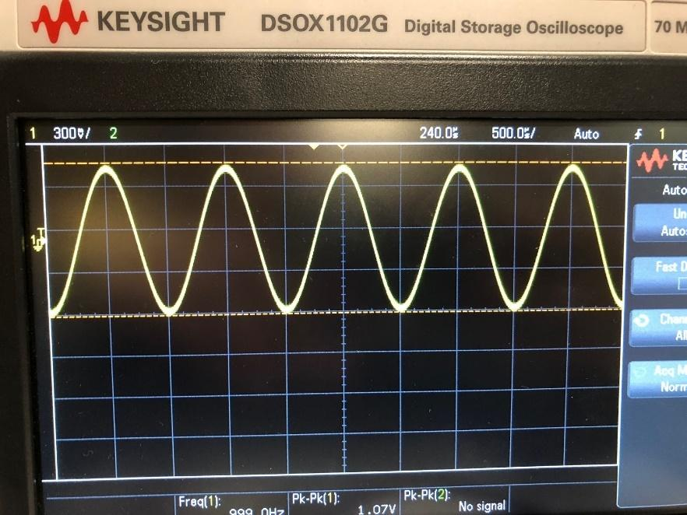

For this step in part 1 we have to create the RC on figure 1. Now for the R value, my group and I had to choose a R value such that it will give us a 45-degree phase shift. To find this R value my group and I used node analysis and a ton of algebraic manipulation to solve for R. The calculation for R gave us about 1617.29 ohms as our R value. My group and I used a 1.6 K ohm resistor for the R value as it was the closes to it. After we have found the value for R will have to connect Vin to the function generator and with a 1-volt p-p at a 1Khz and 0-volt DC offset. Now we connect channel 1 to Vin and channel 2 to Vout. Now we observed the time position of the circuit input and output on the oscilloscope. The two waveforms looked similar but only different by their volt divisions and amplitude.

A screenshot of a cell phone

Description generated with very high confidence

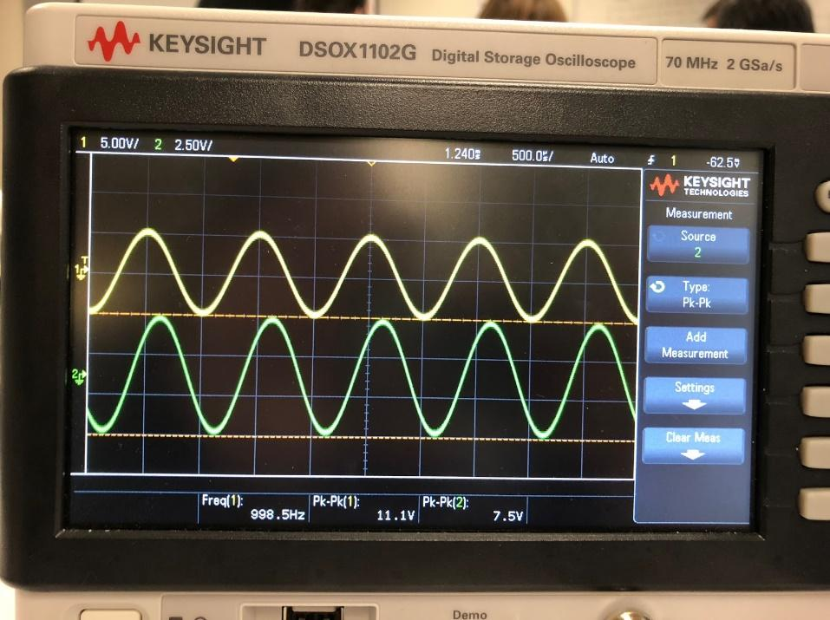

|  |  |  |  |
| --- | --- | --- | --- |
| Resistors | Specified | Measured | Percent Error |
| Ro | 100K ohms | 101.87 K ohms |  |
| R | 1.6K ohms | 1.58 K ohms |  |

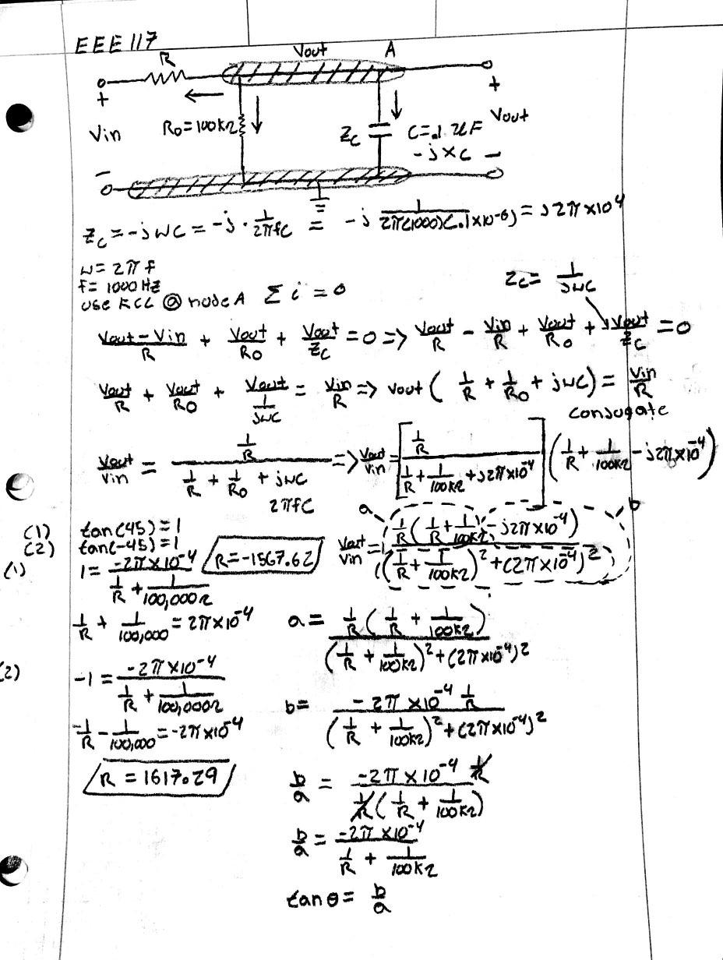

Now will adjust the vertical position of channel 2 until its off the screen and notice the arrow that pops up when the signal is off the screen. The signal was telling my group and I the pointing to the direction where the signal is. Now will repeat but this time were moving channel two signal at the bottom of the screen. This was a great way to just isolate one waveform or position a wave form properly so that we can measure it visually.

Part II

Triggering controls first step was to use the 1-volt peak to peek sin wave from part I and set the oscilloscope to SOURCE and select the channel 1. Next, we set the mode to NORM and turn the level control until we see a straight line across the screen. The oscilloscope should trigger when the line intersects the signal voltage. During this step we can change the time reference by selecting main/delayed and the TIME REFERENCE from the on-screen menu. My group and I also noticed the caret at the top of the screen which indicates the time reference points.

Now will select go over the triggering control section and select “CLOPE/COPLING” and from the menu we select “+/-“ . Finally, we toggled the triggering mode from ATOU to NORM. Now we take all our observations from the step we have just gone over for part II.

|  |  |
| --- | --- |
| Observe When: | Observations: |
| Trigger Level Changes | When we change the time reference to the center the trigger points go to the center of the sine wave there is a 500 microsecond delay. When it changes to the left reference, the carats go to the left of the sine wave. |
|
| Toggled from + to - | Trigger is changed to 0 volts. When we change between the rising slope and the falling slope, they seem to be the inverse of each other. |
|
| Toggled from "AUTO" to "NORM" (Within the signal voltage) | When changing between norm and auto is doesn’t change anything. |
|
| Toggled from "AUTO" to "NORM" (Outside the signal voltage) | The frequency of the wave changes frequently between 999.4 kHz and 1.0006Hz  when it is in auto. When it is in normal, the sine wave frequency is stable. |
|

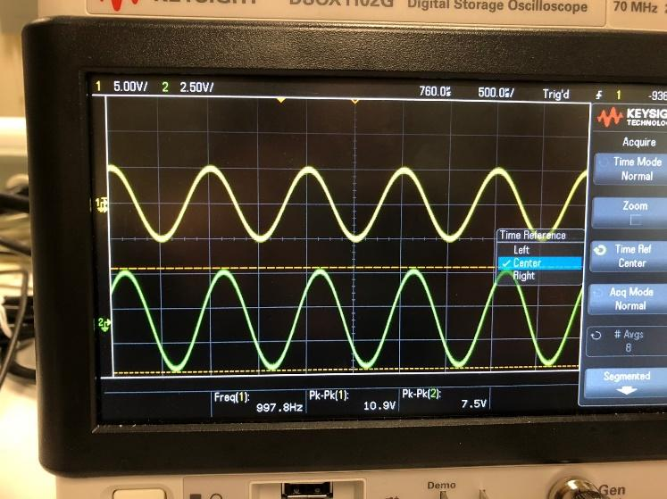 Center

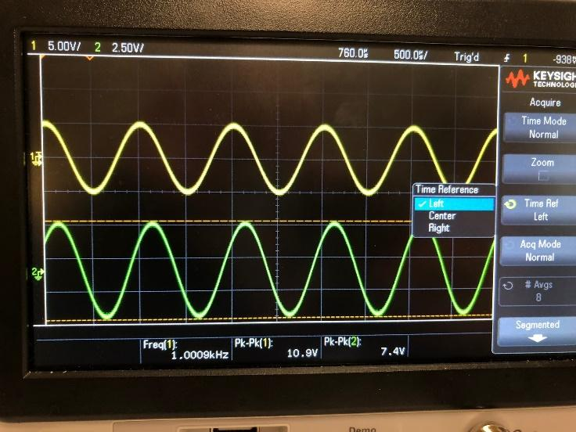Left Trigger

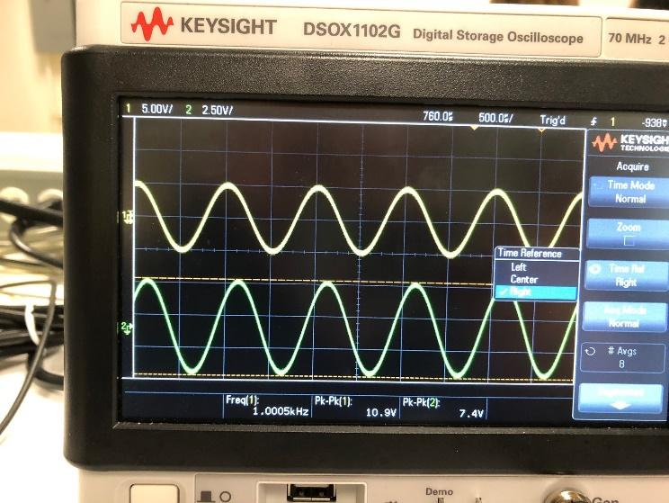Right Trigger

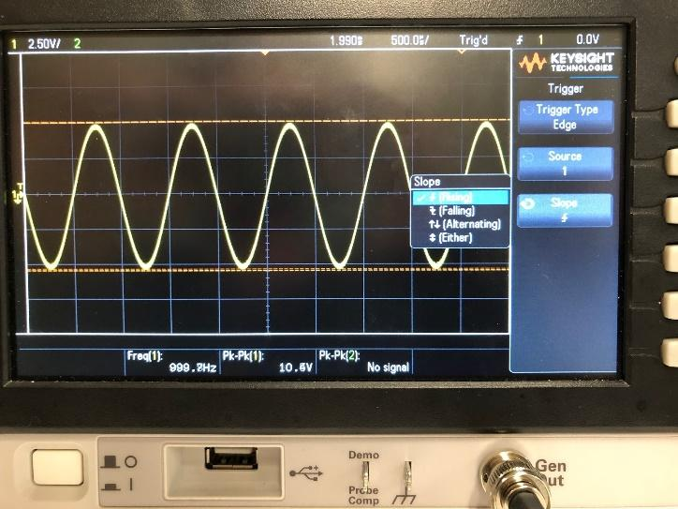Rising +

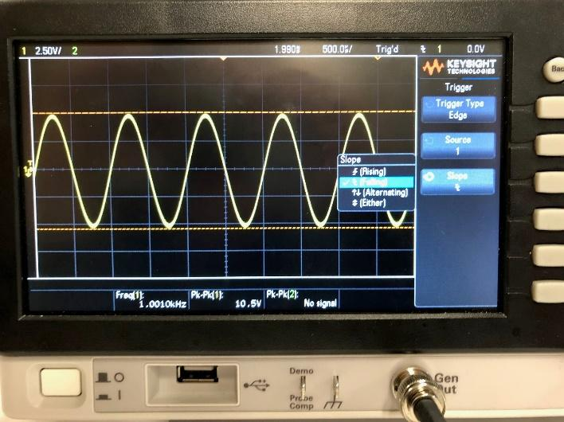Falling –

Part III

Measurements

First will set the function generator to 1 Vp-p at 1KHz sine wave with a 0-volt DC offset. Now will connect the function generator to the digital multimeter and to channel 2. My group and I made sure that we were using the x10 probe on the oscilloscope. Next, we had to select the Voltage and from the menu we choose channel 2 and measure Vp-p and Vrms for the waveform. To measure the Vrms value of the wave forms we used the DMM and the readings were consistent because we were comparing the Vrms value from the DMM to the one on the oscilloscope. Now we connect a 51-ohm resistor across the function generator and repeat are previous steps on the readings. Lastly will connect the R-C circuit of figure 1 and measure the RMS voltage of both waveforms from channel 1 and channel 2. Now my group an I had to measure the period and time delay between the two waveforms. To achieve this my group mates and I added the measurements for period and time delay on the oscilloscope. fortunately, the oscilloscope provided to us allow us to add all sorts of measurements we need. Next, we had verify that are frequency and period are consistent and start our calculations.

|  |  |  |  |  |  |  |  |
| --- | --- | --- | --- | --- | --- | --- | --- |
| Element | Voltage (P-P) | Voltage AC rms | Frequency | Time Delay | Period | Phase Shift | Magnitude |
| RMS Waveform 1(measured) (Part 1) | 7.4 V | 2.4969 V (scope)  .283 V (DMM) | 999.5 Hz | 0.0 s | 1.0005ms | 0.0 degrees | 7.4 V |
| RMS Waveform 1(calculated) | N/A | N/A | N/A | N/A | N/A | 0.0 |  |
|  |  |  |  |  |  |  |  |
| RMS Waveform 2(measured) (Part 2) | 540 mV | 179.4 mV (Scope) .178 V (DMM) | 999.23 kHz | 0.0s | 999.67 microseconds | 0.0 degrees | 540 mV |
| RMS Waveform 2(calculated) | N/A | N/A | N/A | N/A | N/A | 0.0 |  |
|  |  |  |  |  |  |  |  |
| RMS Waveform 3(measured) Ch1 | 1.09 V | 352.8 mV | 998.82 kHz | 122.91 microseconds | 999.12 microseconds | 43.70 degrees | 1.09 V |
| RMS Waveform 3(calculated) Ch1 | N/A | N/A | N/A | N/A | N/A | 44.28 |  |
| RMS Waveform 3(measured) Ch2 | 740 mV | 250.45mV | 999.82 kHz | 122.91 microseconds | 999.30 microsec | 43.70 degrees | 740 mV |
| RMS Waveform 3(calculated) Ch2 | N/A | N/A | N/A | N/A | N/A | 44.27 |  |

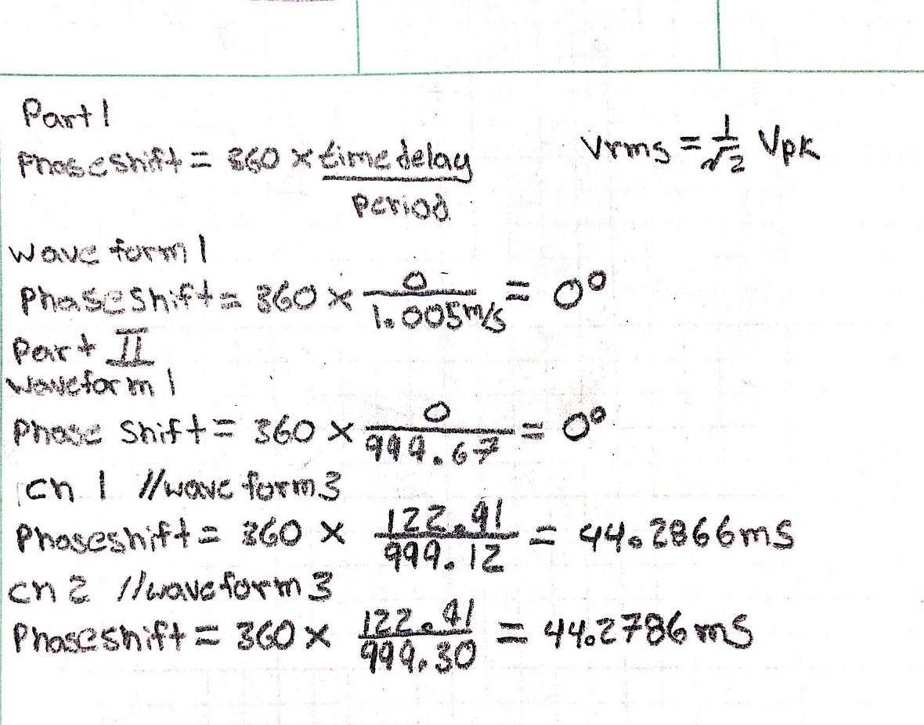

**4 Conclusion**

We have shown how to properly use an oscilloscope, function generator and digital multimeter through our observations and calculations. With the observation my group mates and I have made I was able to learn more about the oscilloscope’s controls and measurements. For part 1 I found that the x10 and x1 probes both give off the same readings and are therefore both accurate. Also learned that a DC off set shifts the waveform on the Y axis and changing the coupling from DC to AC did not affect the waveform. Through my calculations for R I was able to find the resistance value to be about 1617.29 ohms. This R value aloud my group and I to obtain about a 45-degree phase shift angle. For part 2 triggering controls my group mates and I observed many parts that allowed us to learn more about the oscilloscope. We learned more about the triggering levels, + & - toggles, and toggling between NORM and ATUO settings on the oscilloscope. For part 3 I learned how to take measurements out of the oscilloscope properly. To verify my measurements, I took calculations to insure my results were accurate. Unfortunately, my group mates and I were not able to get proper results for our magnitude calculations. Possible sources of error could have been improper readings or not using the correct equations to solve for magnitude. Thus, explaining why boxes are blank for calculated magnitude. Therefore, concluding my lab on the oscilloscope.